1. Given an array of integers, find the maximum difference between any two elements in the array.

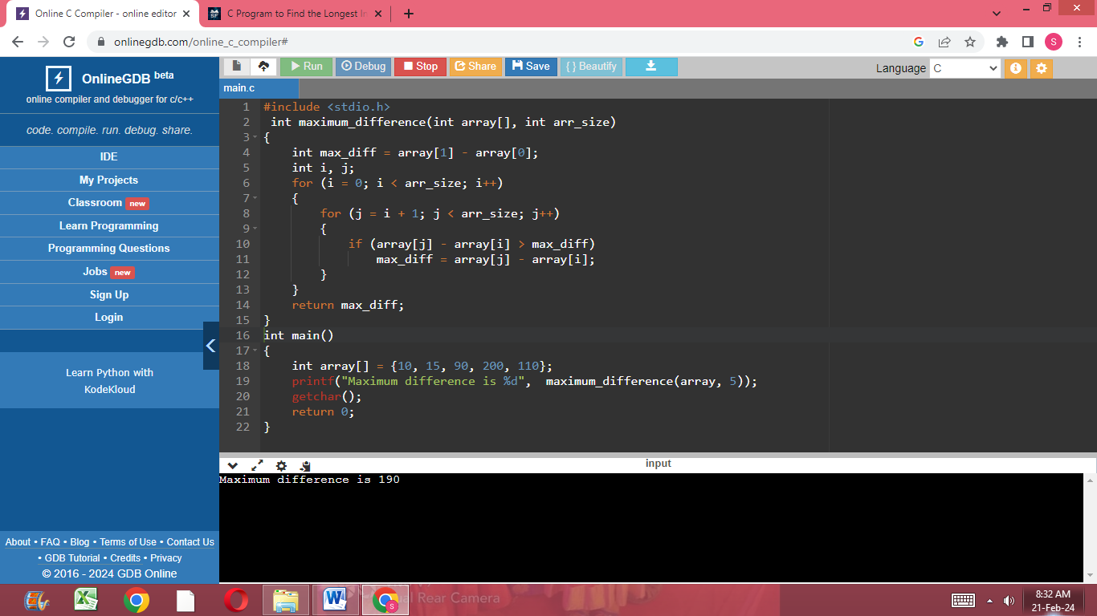

1. Given an array of integers, find the longest increasing subarray.

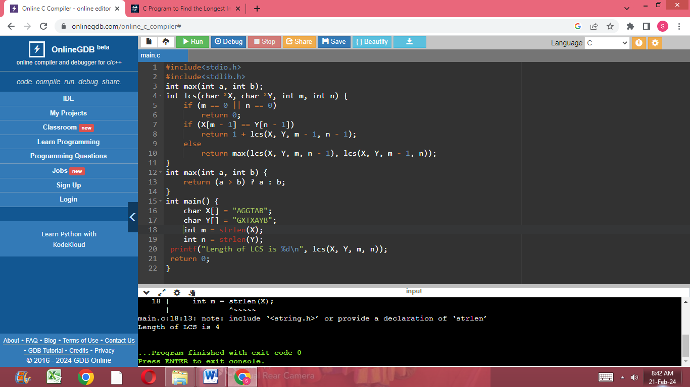

1. Given two arrays of integers, find the common elements between them.

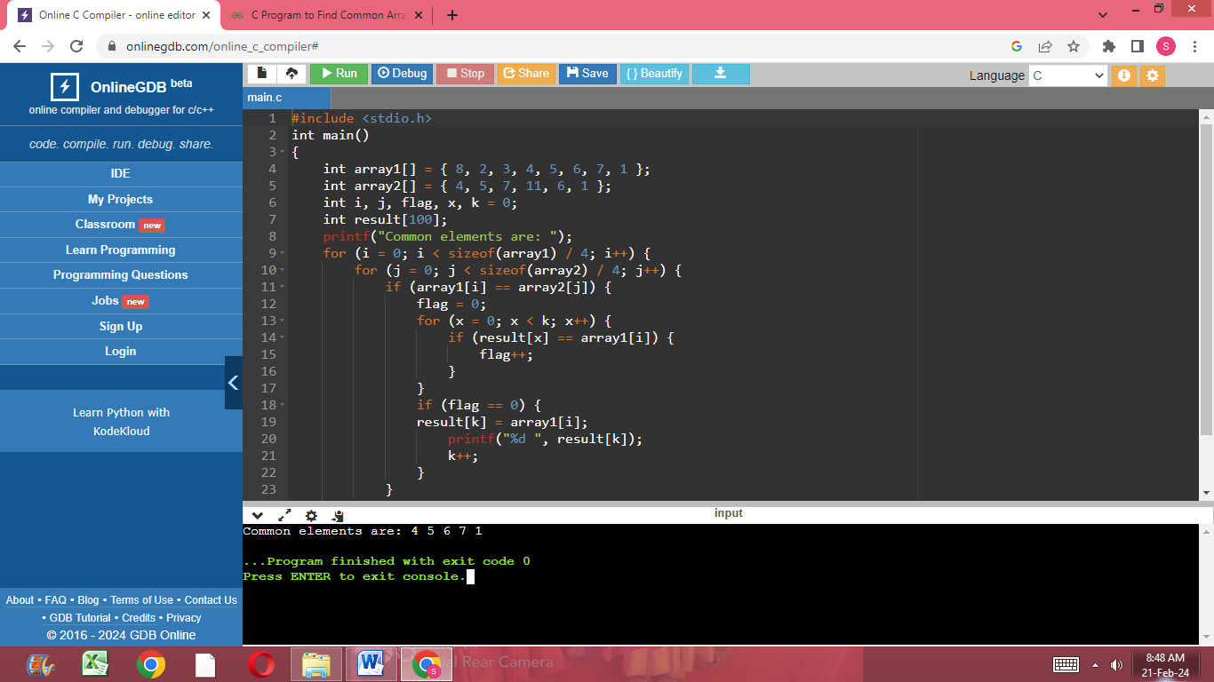

1. Given an array of integers, find the element that appears more than n/2 times (where n is the size of the array).

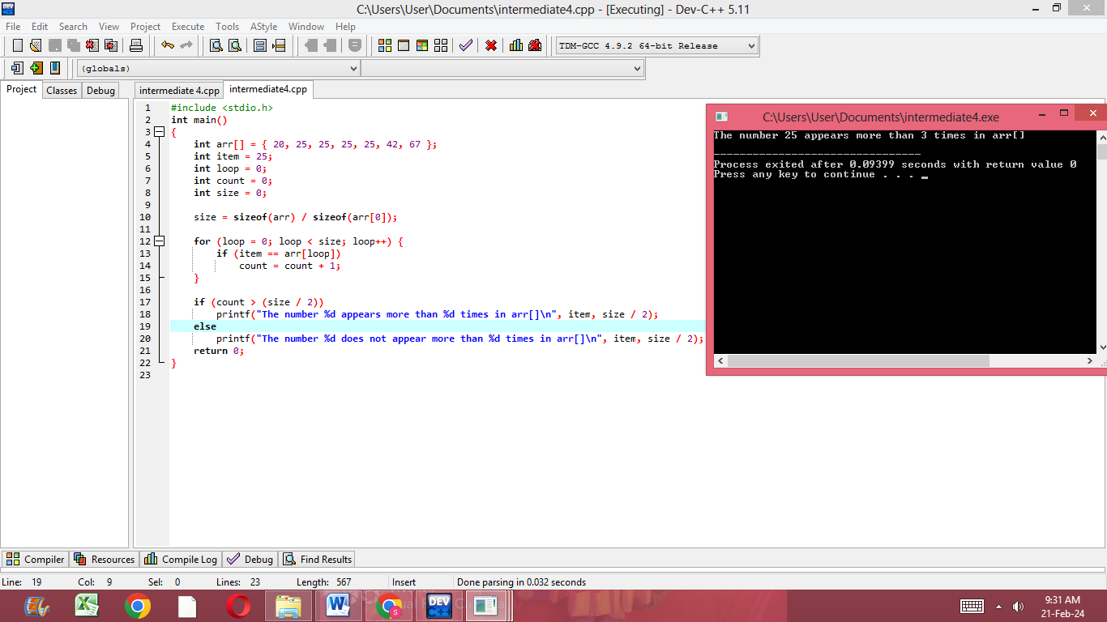

1. Given an array of integers, rearrange the elements in such a way that all the negative elements come before the positive elements.

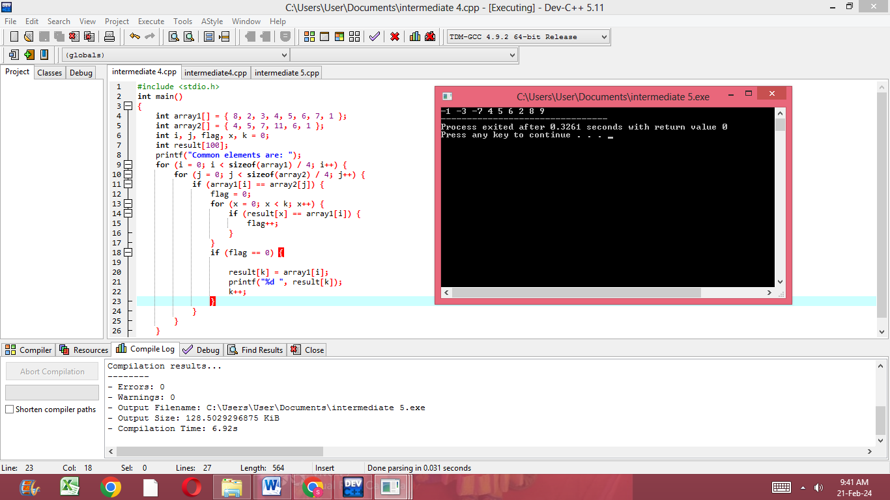

1. Given an array of integers, find the majority element (an element that appears more than n/2 times, where n is the size of the array) if it exists.

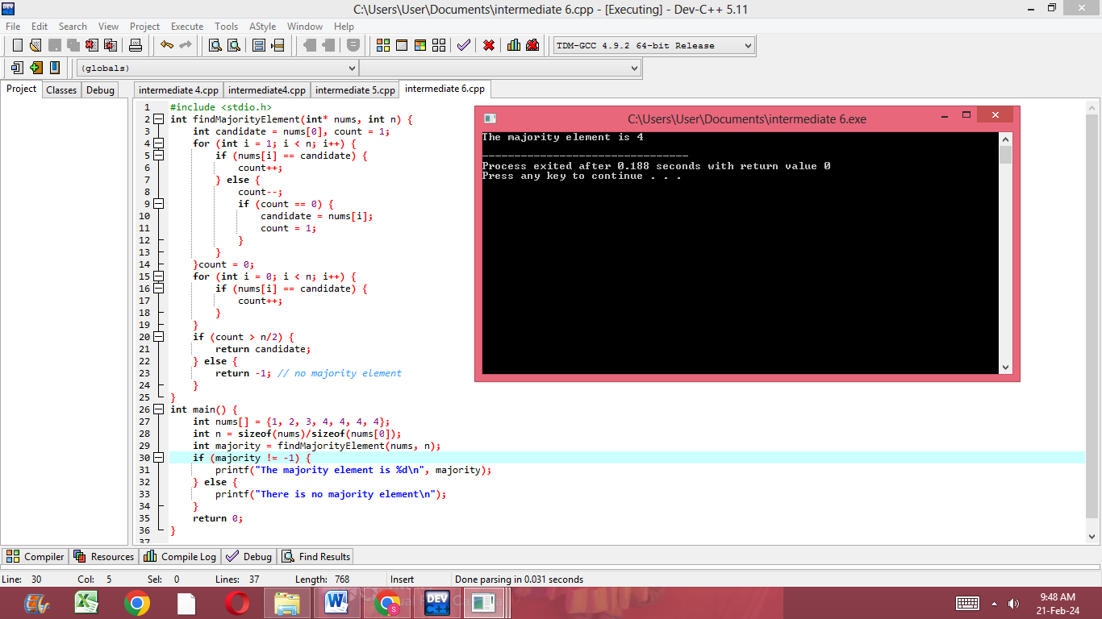

1. Given an array of integers, find the subarray with the largest sum.

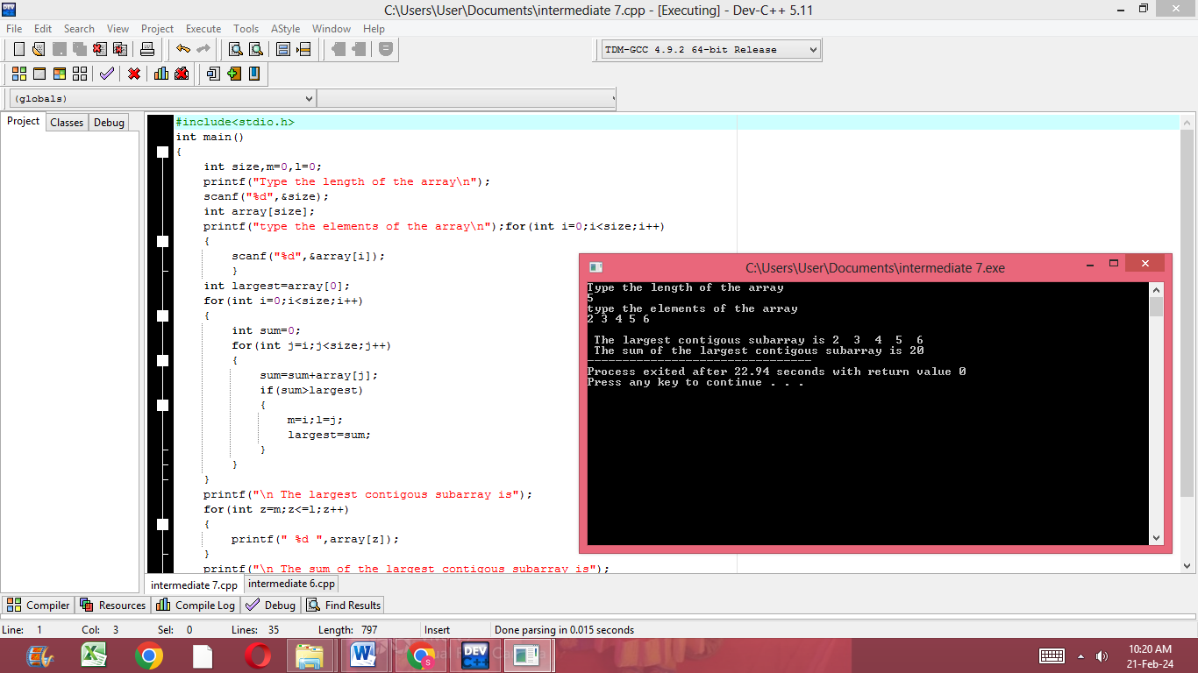

1. Given an array of integers, rotate the array by k positions to the right.

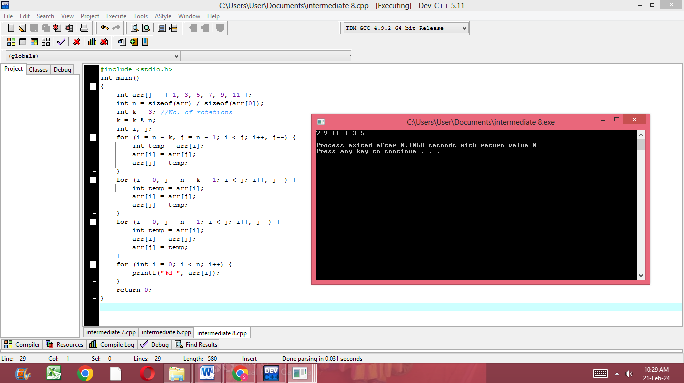

1. Given an array of integers, rearrange the array in such a way that all the even elements come before the odd elements.

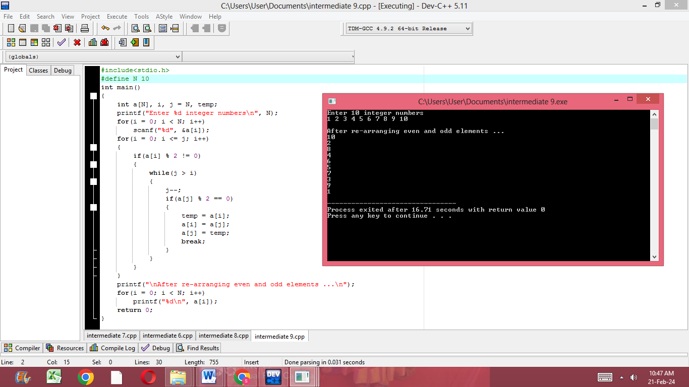

1. Given an array of integers, find the longest subarray with equal number of 0s and 1s.

